



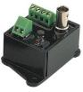
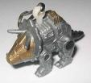
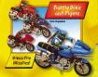
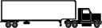
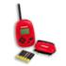
kite
£1.25
£1.30
£2.80
£3.60
£4.30
50p
£4.50
£2.20
£3.50
£2.75

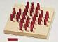
Peg board

teddy
Angel bear

£2.40

aeroplane
Legoswitch
clips
Walkie-talkie


keyring
truck
motorbikes

GROUP ONE
Make some problems. Pick two toys each time and add up the prices.
Item | Price
Total

GROUP TWO
Make a till receipt for toys which have
been bought.
Add up three toys at the same time.

