Radians
Radians, like degrees, are a way of measuring angles.

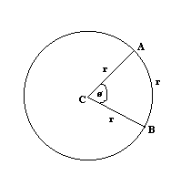

One radian is equal to the angle formed when the arc opposite the angle is equal to the radius of the circle. So in the above diagram, the angle ø is equal to one radian since the arc AB is the same length as the radius of the circle.
Now, the circumference of the circle is 2πr, where r is the radius of the circle. So the circumference of a circle is 2π larger than its radius. This means that in any circle, there are 2π radians.
Therefore 360º = 2π radians.
Therefore 180º = π radians.
So one radian = 180/π degrees and one degree = π/180 radians.
Therefore to convert a certain number of degrees in to radians, multiply the number of degrees by π/180 (for example, 90º = 90 × π/180 radians = π/2). To convert a certain number of radians into degrees, multiply the number of radians by 180/π .
Arc Length
The length of an arc of a circle is equal to rø, where ø is the angle, in radians, subtended by the arc at the centre of the circle (see below diagram if you don’t understand). So in the below diagram, s = rø .

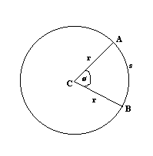

Area of Sector
The area of a sector of a circle is ½ r² ø, where r is the radius and ø the angle in radians subtended by the arc at the centre of the circle. So in the below diagram, the shaded area is equal to ½ r² ø .

