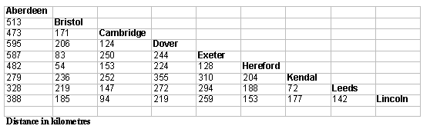
Tom is using the chart above to find out information for his mum about the distances for their coming holiday to Scotland.
Tom lives in Hereford.
1. Tom's mum tells him that they are going to Aberdeen by car and it is approximately 500 kilometres. Is she right?
2. What is the distance by the chart from Hereford to Aberdeen?
___
3. On the way to Aberdeen they will be visiting Tom's uncle in Leeds.
So the journey will be from Hereford to Leeds, then from Leeds to Aberdeen.
What is the total distance travelled to get to their holiday destination?

(b) After the holiday they will drive straight back to Hereford.
What will be the total distance travelled there and back?

