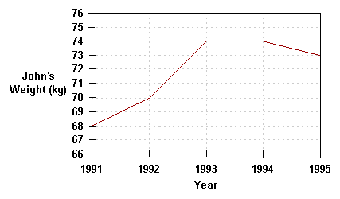

This line graph shows John’s weight over a period of 5 years.

What did John weight in 1992?

1993

1994

1995?

