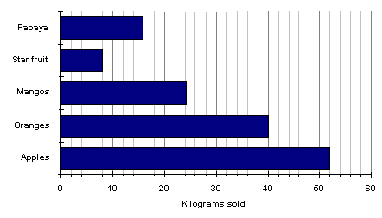

This bar chart shows how much fruit was sold in one day.

How many kilograms of Oranges were sold?

Apples?

Star Fruit?

Mangos?

Papaya?

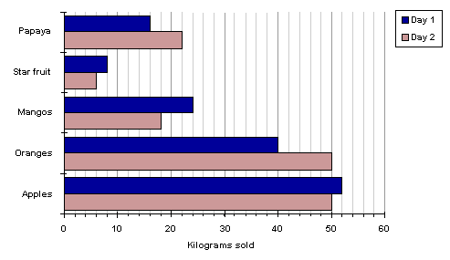

This chart shows how much fruit was sold in two days.

How many more Apples were sold on the second day?

Oranges?

Mangos?

Star fruit?

Papaya?

