EQ22 Norwich - Spixworth - Frettenham

Eastern Counties 8 / 10 / 10A
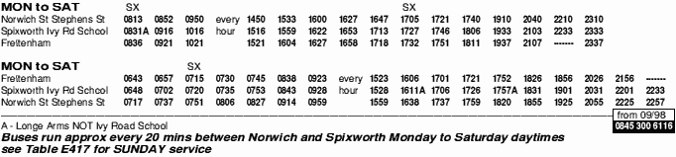
Norwich, Old Catton, Spixworth and Frettenham

Using the above bus timetable answer the following questions:-

- How often do the buses run between Norwich and Spixworth?

- What time does the 6:43 bus from Frettenham reach Norwich?

- How long does it take to get from Spixworth to Norwich?

- How long does it take to get from Frettenham to Spixworth?

- If I caught the bus at 7:15 at Frettenham, what time would I reach Norwich?

- What time does the last bus leave Frettenham?

- What time does the first bus leave Norwich?

