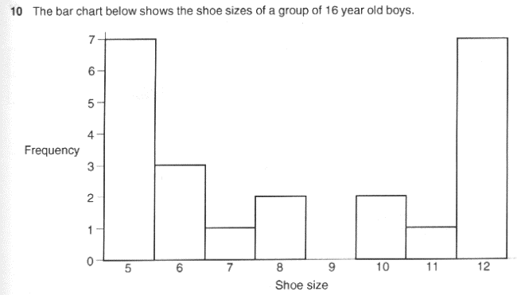

- How many boys wear size 12 shoes?

- How many boys wear size 6 shoes?

- How many more wear a size 5?

- How many boys took part in the survey?

