1. Express 0.327 × 10⁵ in standard form.

2. A US Centillion is the number ${\text{10}}^{\text{303}}$
A UK Centillion is the number ${\text{10}}^{\text{600}}$

a How many US Centillions are there in a UK Centillion? Give your answer in standard form.
b Write the number 40 US Centillions in standard form.

3. Do NOT use a calculator for this question.
You must show all your working.
Work out 453 × 73.

4. It takes 6 men 8 days to build a wall.
All the men work at the same rate.
How long would it take 4 men to build a wall the same size?

5. Cedric buys 12 pencils for £3.48.
Work out the cost of 20 pencils.

6. i Write down two numbers you could use to estimate the answer to 793 ÷ 21
ii Work out your estimate.

7. Malika's father won £128.
He shared the £128 between his three children in the ratio 6:3:1.
Malika was given the biggest share.
a Work out how much money Malika received.
Malika saved $\frac{2}{3}$of her share.
b Work out how much Malika saved.

8. Marcus see a motorbike advertised for £750.
This is the price after a reduction of 15%.
Work out the original price of the motorbike.

9. The diagram shows a metal box. 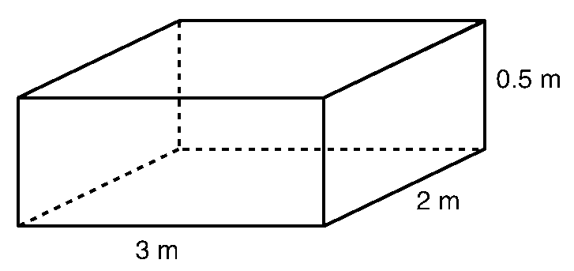
The box is a cuboid.
a Work out the volume, in m³, of the box

Shiftem deliver these boxes in the UK.
They charge £28.85 for each m³ of a box's volume.
b Work out Shiftem's charge for delivering one of these boxes.
The weight of a box is 0.125 tonnes.
c Write 0.125 tonnes in kg.
Le Goff deliver these boxes to Paris.
They charge 7.92 French francs for each kg.
d Work out Le Goff's charge, in French francs, for delivering one of these boxes.
Le Goff deliver 50 of these boxes to Paris.
£1 = 8.85 French francs.
e Work out Le Goff's charge, in £, for delivering the 50 boxes. Give your answer correct to the nearest £.

10. The perimeter of this triangle is 31 cm.
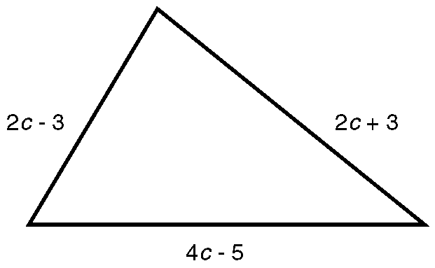
Work out the value of c.

11. a Reflect shape S in the line x = 0. Label the new shape T.
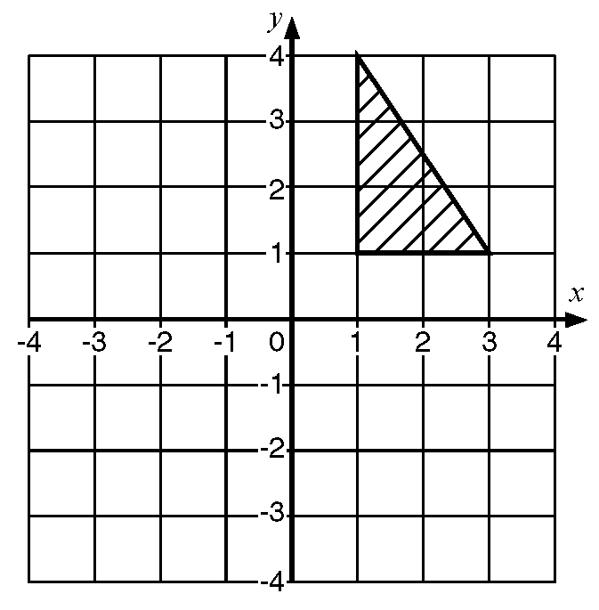

b Rotate the new shape T through an angle of 90º anticlockwise using (0, 0) as the centre of rotation. Label the new shape U.
c Describe fully the single transformation that will move shape U back onto shape S.

12. Some oil is spilt. The spilt oil is in the shape of a circle.
The circle has a diameter of 12 centimetres.

a Work out the circumference, in cm, of the spilt oil. Give your answer correct to 1 decimal place.

The diameter of the spilt oil increases by 30%
b Work out the new diameter, in centimetres, of the spilt oil.

13. Natalie measured the distance between two points on a map. The distance she measured was 5 cm correct to the nearest centimetre.

a Write down the
i least upper bound of the measurement,
ii greatest lower bound of the measurement,

The scale of the map is 1 to 20 000
b Work out the actual distance in real life between the upper and lower bounds. Give your answer in kilometres.

14. a Complete this table of values for y = 3x - 1.
b Draw the graph of y = 3x - 1.
c Use your graph to find
i the value of x when y = 3.5
ii the value of y when x = -1.5

15. Solve the following equations:
i 3p + 5 = 29
ii 5(q - 3) = 25
iii 6r - 5 = 7 - 2r

16. a Write, in symbols, the rule "To find y, multiply k by 3 and then subtract 1"
b Work out the value of k when y = 14.

17. Simplify:
i 2x + 3x
ii h × h × h × h × h
iii 2m × 3n
iv 2(x + 3) + 5(x - 3)

18. The diagram shows part of a distance/time graph for a bus after if had left a bus stop.
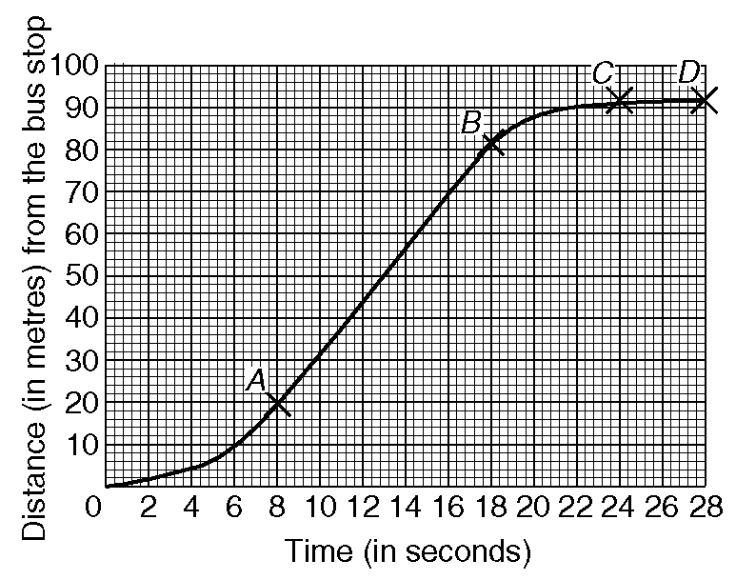
a Use the graph to find the distance the bus travelled in the first 20 seconds after it had left the bus stop.
b Describe fully the journey of the bus represented by the parts AB,BC and CD of the graph.

19. Here are the first five numbers in a simple number sequence.
1, 3, 7, 13, 21, ....., .....

a Write down the next two numbers in the sequence.
b Describe, in words, the rule to continue this sequence.

20. Here are the first terms of a number sequence.
5, 8, 11, 14, 17,
Write down an expression for the nth term of the sequence.

21. Fatima has 35 CDs and tapes.
The ratio of the number of CDs to the number of tapes is 3:4.
Work out how many CDs she has.

22. a Simplify
i 12x⁵ × 3y³ ii (4p²q³)²
9x²y

b Factorise completely
i 9a²b³ + 15a³b² ii x² + 7x - 60
c On a number line, show the solution to these inequalities -7 ≤ 2x - 3 < 3

23. Use a trial and improvement method to solve the equation x³ - x = 15

Complete the working below and find a solution correct to one decimal place.
24. Pippa collected data for the heights (h) of the students in her class.
Here is the grouped frequency table of her results.
a Use the table to calculate an estimate of the mean for her results.
b Complete the cumulative frequency table for Pippa's data and hence draw a cumulative frequency graph for the data.

c Use the cumulative frequency graph to calculate an estimate of
i median of the data
ii interquartile range of the data

25. Rods can be fixed together using bolts.
The diagrams show rods fixed together to form a pattern of hexagons in a row.
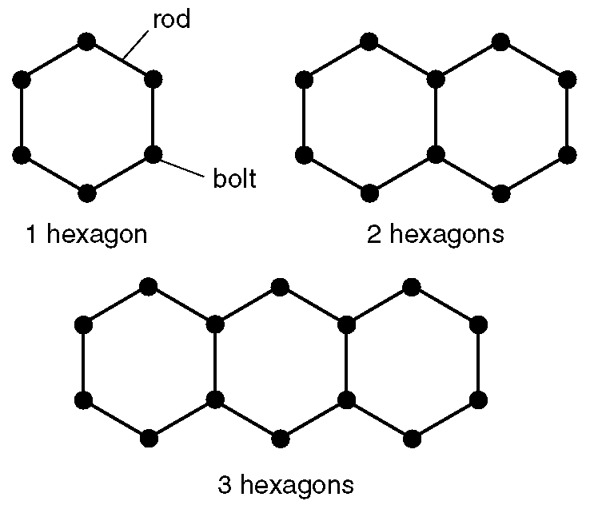
a Complete the diagram below to show how rods can be fixed together to form a pattern of 4 hexagons in a row.
b Complete the table
c Work out the number of bolts needed to form a pattern of 15 hexagons in a row.

26. x is an integer, such that -3 < x 2.
List all the possible values of x.

27. Solve the simultaneous equations
3x + 2y = 11
x - y = 7

28. The expressions shown below can be used to calculate lengths, areas or volumes of various shapes.
The letters r and h represent lengths. π, 2, 3, 4, 5 and 10 are numbers which have no dimensions.
r(r + 4h)
Draw a circle around each of the expressions which can be used to calculate an area.

29. In the diagram AB = 17.9 m,
BD = 8.2 m, angle CBD = 37º
and angle BDC = 90º.

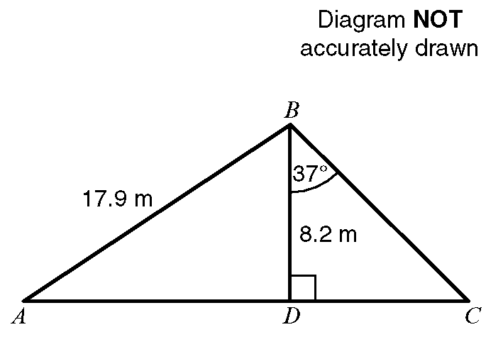

ADC is a straight line.
a Calculate the length of DC.
Give your answer, in metres, correct to 3 significant figures.
b Calculate the size of angle DAB. Give your answer correct to 1 decimal place.

30. a Draw the graphs of:
i x + y = 4 ii y = x + 2

b Use the graphs to solve the simultaneous equations:
x + y = 4
y = x + 2

31. Calculate the length of a diagonal of this rectangle.
Give your answer in centimetres correct to one decimal place.

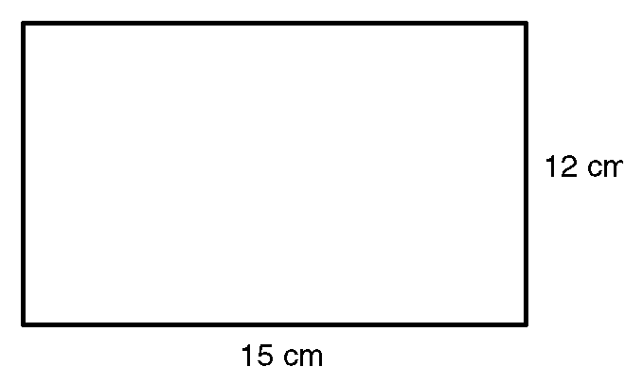

32. a The diagram shows a quadrilateral
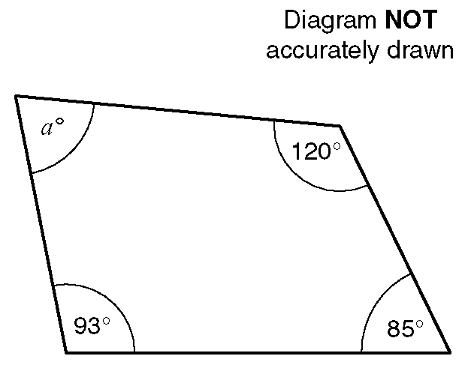
Work out the size of the angle marked aº.

b The diagram shows a regular hexagon.
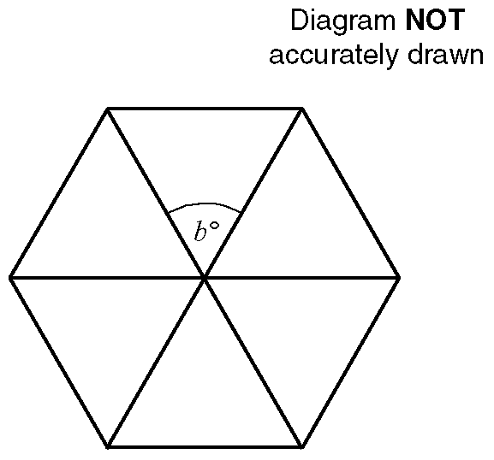
Work out the size of the angle marked bº.

c The diagram shows a regular octagon.
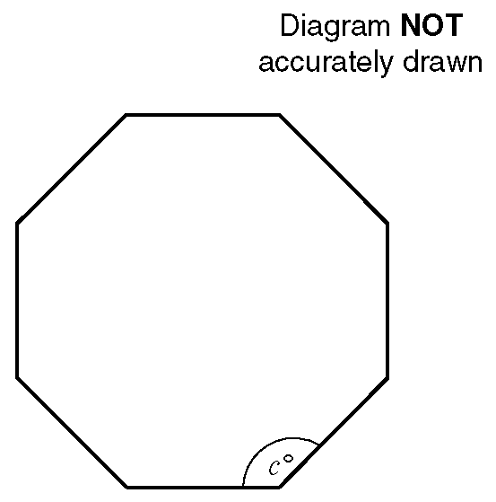
Work out the size of the angle marked cº.
33. The scale drawing below shows the positions of an airport tower, T, and a radio mast, M.

1 cm on the diagram represents 20 km.
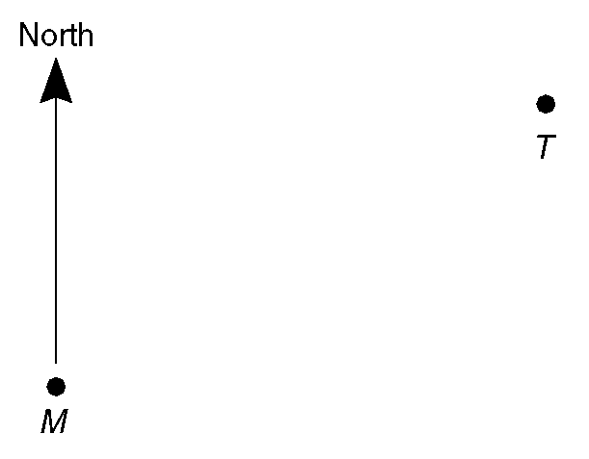
a i Measure, in centimetres, the distance
TM.
ii Work out the distance in km of the airport tower from the radio mast.
b i Measure and write down the bearing
of the airport tower from
the radio mast.
ii Write down the bearing of the radio mast from the airport tower.

A plane is 80 km from the radio mast on a bearing of 220º.

c Plot the position of the plane, using a scale of 1 cm to 20 km on the scale diagram.

34. The diagram shows a triangular prism.

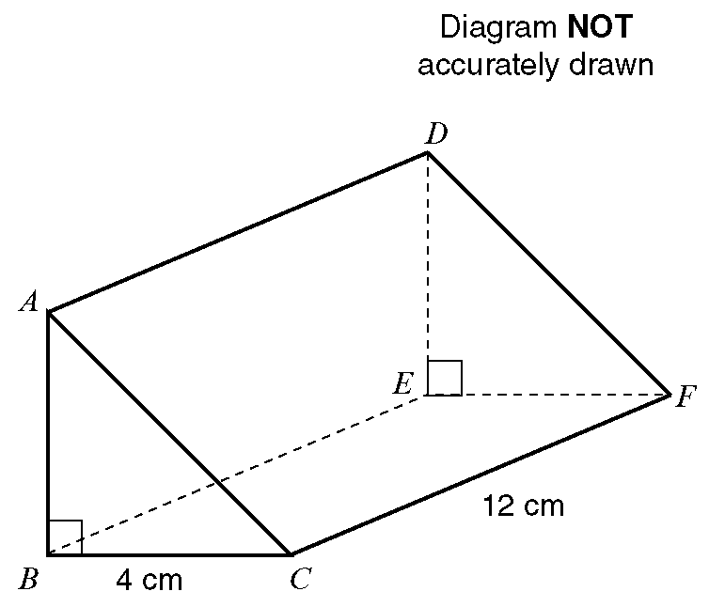

BC = 4 cm, CF = 12 cm and angle ABC = 90º.
The volume of the triangular prism is 84 cm³.
Work out the length of the side AB of the prism.

35. There are 14 pounds in a stone.
There are 2.2 pounds in a kilogram.
A man weighs 13 stone 6 pounds.
Work out his weight in kilograms.
Give your answer to the nearest kilogram.

36. There are 2.54 centimetres in 1 inch.
There are 12 inches in 1 foot.
There are 3 feet in 1 yard.

i Calculate the number of yards in 10 metres.
ii Calculate the number of metres in 10 yards.

37. Alison, Brenda, Claire and Donna are the only runners in a race.
The probabilities of Alison, Brenda and Claire winning the race are shown below.

Work out the probability that Donna will win the race.

38. y = ab + c
Calculate the value of y when
a =$\frac{3}{4}$, b = $\frac{7}{8}$and c =$−\frac{1}{2}$
Give your answer in the form $\frac{p}{q}$ where p and q are integers.

39. A fair coin is tossed and a fair dice is thrown.
One possible outcome is (Heads, 4).
List all the possible outcomes.

40. A game in an amusement arcade can show the following pictures.
The fraction under each picture shows the probability of the picture being shown at the first window.
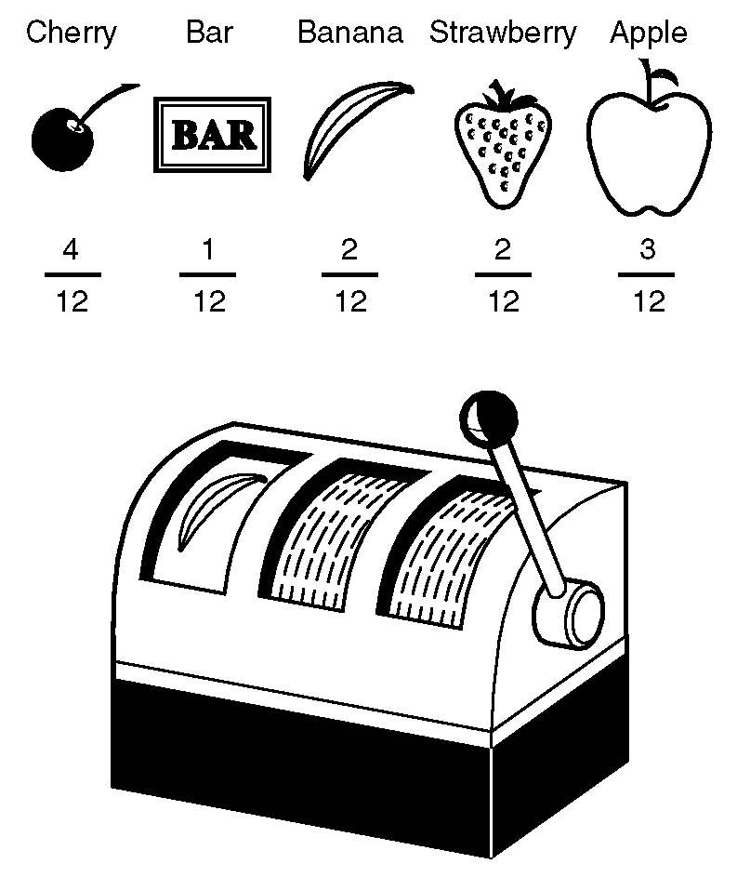
Calculate the probability of the game not showing a Bar at the first window.

41. Two dice with faces numbered 1 to 6 are rolled and the sum of the scores on upward facing faces noted.

a Complete the table of probabilities for the chance of scoring all the totals available.
b Work out the probability that the score will be
i more than 9, ii less than 5,
iii more than 6 and less than 10.

42. Information about oil was recorded each year for 12 years.
The table shows the amount of oil produced (in billions of barrels) and the average price of oil (in £ per barrel).
a Draw a scatter graph to show the information in the table.
b Describe the correlation between the average price of oil and the amount of oil produced.

43. In a town 1800 cars were stolen in a year. The table shows information about the times of day when they were stolen.
This information can be shown in a pie chart.

a Work out the angle of each sector of the pie chart.
b Construct the pie chart.
c What fraction of the number of cars was stolen between Midday and 6pm? Write your fraction in its simplest form.

44. Sidney places the foot of his ladder on horizontal ground and the top against a vertical wall.
The ladder is 16 feet long.
The foot of the ladder is 4 feet from the base of the wall.

a Work out how high up the wall the ladder reaches.
Give your answer to 3 significant figures.
b Work out the angle the base of the ladder makes with the ground.
Give your answer to 3 significant figures.

45. Jomo is going to design a circular roundabout. The roundabout will have a circumference of 7 metres.
Jomo is given three estimates for the length of the diameter of the roundabout.
The estimates are:

2.2278803 metres
2 metres
2.23 metres

a Give a reason why 2.23 metres is the most reasonable estimate to use.

b Explain why 2.2278803 metres and 2 metres are not appropriate to use.

46. Andrew did a survey at the seaside for his science coursework. He measured the lengths of 55 pieces of seaweed. The results of the survey are shown in the table.

Andrew needs to calculate an estimate for the mean length of the pieces of seaweed.

a Work out an estimate for the mean length of the piece of seaweed. Give your answer correct to 1 decimal place.
b Write down the interval which contains the median length of a piece of seaweed.

