

MIDLAND EXAMINING GROUP 1662/5

General Certificate of Secondary Education

MATHEMATICS SYLLABUS A
PAPER 5 (Higher Tier)
SPECIMEN PAPER
Candidates answer on the question paper.
Additional materials:
Electronic calculator
Geometrical instruments
Tracing paper (optional)
TIME 2 hours
INSTRUCTIONS TO CANDIDATES
Write your name, Centre number and candidate number in the spaces at the top of this page.
Answer all questions.
Write your answers in the spaces provided on the question paper.
Show all your working. Marks may be given for working which shows that you know how to solve the problem, even if you get the answer wrong.
INFORMATION FOR CANDIDATES
The number of marks is given in brackets [ ] at the end of each question or part question.
You are expected to use an electronic calculator for this paper.
Unless otherwise instructed in the question, take to be 3.142 or use the button on your calculator.

Formulae Sheet : Higher Tier
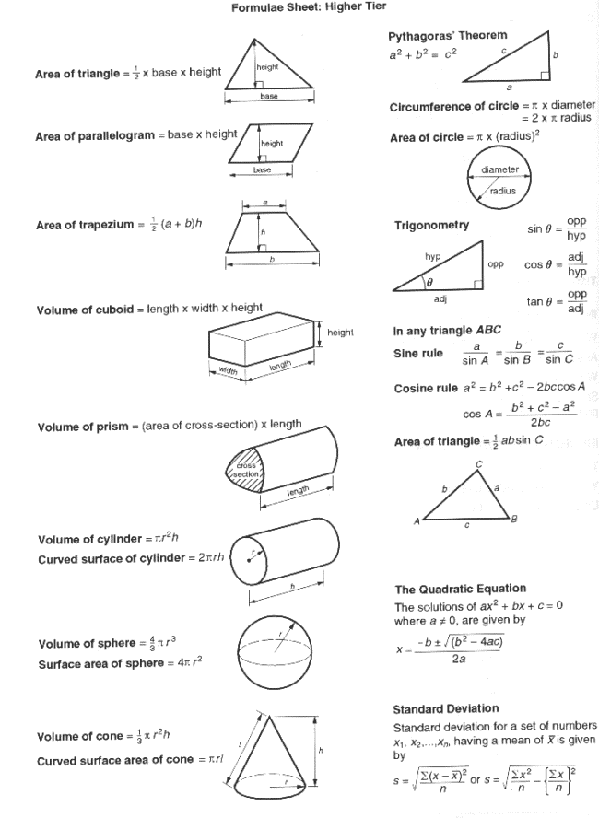

1 At the end of 1993 there were 5000 members of a certain rare breed of animal remaining in the world.
It is predicted that their number will decrease by 12% each year.
(a) How many will be left at the end of 1996?
......................................................................................................................................................
......................................................................................................................................................
......................................................................................................................................................
Answer (a) ______________________________________ [3]
(b) By the end of which year will the number first be less than 2500?
....................................................................................................................................................
......................................................................................................................................................
......................................................................................................................................................
Answer (b) ______________________________________ [2]

2 Ten boys of different ages were set the same General Knowledge test.
The results have been plotted on the scatter graph below.
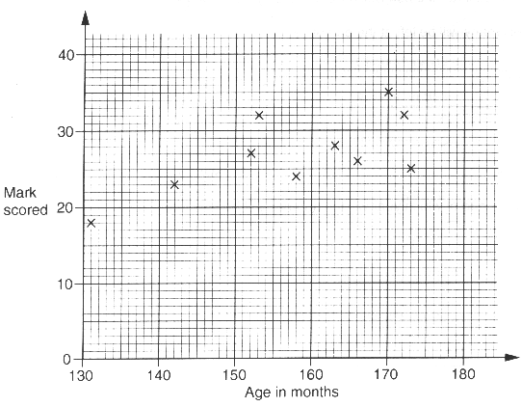
(a) Does the scatter graph show the sort of result you would expect? Explain your answer.
Answer (a) __________________________________________
___________________________________________________________________________
_______________________________________________________________________ [2]
(b) Add a line of best fit to the scatter graph.[2]
(c) Taking age into account, to which boy would you award a prize for the best performance?
Give the boy's age and mark scored.
Answer (c) Age = ________ months, Mark = ________ [1]

3
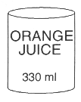
A cylindrical can of orange juice has an internal base radius of 3.2 cm and a volume of 330 ml.
Calculate the internal height of the can. Give your answer correct to an appropriate number of significant figures.
......................................................................................................................................................
......................................................................................................................................................
......................................................................................................................................................
......................................................................................................................................................
......................................................................................................................................................
Answer __________________________________________ [4]

4 Solve the equations
(a)
7 x = 56,
2

......................................................................................................................................................
Answer (a) x = __________________________________ [2]
(b) 6y + 5 = 14,
......................................................................................................................................................
......................................................................................................................................................
Answer (b) y = __________________________________ [2]
(c) 2z + 6 = 21 - z.
......................................................................................................................................................
......................................................................................................................................................
......................................................................................................................................................
Answer (c) z = __________________________________ [2]

5
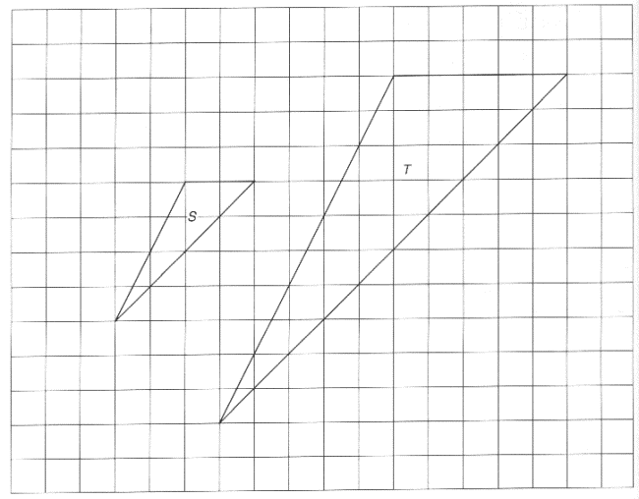
In the diagram, triangle T is an enlargement of triangle S from a centre C.
(a) In the diagram, mark and label the centre of enlargement C. [2]
(b) Write down the scale factor of the enlargement.
Answer (b) ______________________________________ [1]

6 A number x is such that
x 1/2 = 1/5 .
(a) Find the value of x 3/2 .
......................................................................................................................................................
......................................................................................................................................................
Answer (a) ______________________________________ [1]
(b) Find the value of x¯¹.
......................................................................................................................................................
......................................................................................................................................................
Answer (b) ______________________________________ [2]

7
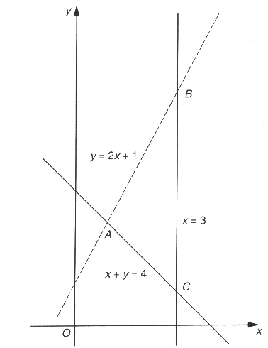
Write down the three inequalities which define the triangular region ABC.
Answer ______________________________________________
___________________________________________________________________________
_______________________________________________________________________ [3]

8
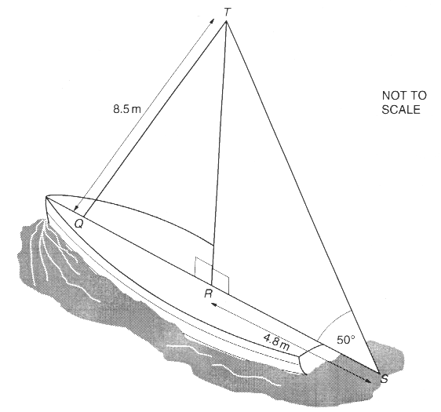
The triangular sail, TRS, of a small boat has a right angle at R.
RS = 4.8 m. Angle TSR = 50°. The sail is attached to a vertical mast.
(a) Calculate the height, TR, of the mast.
......................................................................................................................................................
......................................................................................................................................................
......................................................................................................................................................
Answer (a) ____________________________________ m [2]
(b) The mast is held in position by a rope, TQ, of length 8.5 m. Angle TRQ = 90°.
Calculate the angle between TQ and the mast.
......................................................................................................................................................
......................................................................................................................................................
......................................................................................................................................................
Answer (b) ______________________________________ [3]

9
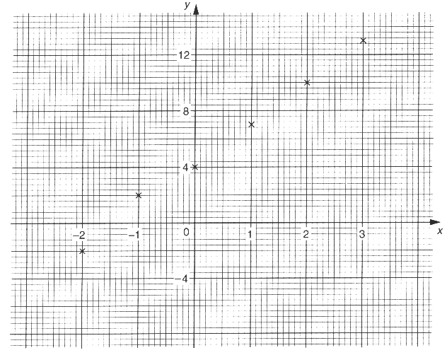
Beth was asked to draw the graph of y = 3x + 4.
She plotted the six points shown in the diagram above.
(a) (i) From the shape of the graph, how can you tell that one of the points is in the wrong place?
Answer (a) (i) ______________________________________
_______________________________________________________________________ [1]
i(ii) On the diagram, draw the graph of y = 3x + 4. [1]
(b) By drawing another straight line on the diagram, solve the simultaneous equations
y = 3x + 4,
y = 2 - x.
Answer (b) x = ___________ , y = __________ [4]

10 (a) Expand (2x - p)², giving your answer in its simplest form.
......................................................................................................................................................
......................................................................................................................................................
Answer (a) ______________________________________ [2]
(b) Find a value of p and the corresponding value of k such that, for all values of x,
(2x - p)² = 4x ² + kx + 9.
......................................................................................................................................................
......................................................................................................................................................
......................................................................................................................................................
Answer (b) p = _____________ , k = ______________ [2]

11
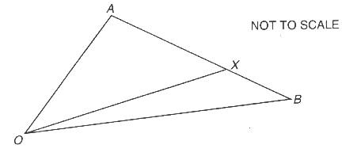
In the diagram X is the point on AB such that AX = 3XB.
Given that OA = 8a and OB = 4b, express in terms of a and/or b
(a) (i) AB,
......................................................................................................................................................
Answer (a) (i) __________________________________ [1]
(ii) AX,
......................................................................................................................................................
Answer (a) (ii) _________________________________ [2]
(b) OX.
......................................................................................................................................................
......................................................................................................................................................
......................................................................................................................................................
Answer (b) ______________________________________ [2]

12 The number of coins, N, with diameter d cm and with a fixed thickness that can be made from a given volume of metal can be found by using the formula
N = k
d²
where k is a constant.
(a) Given that 5000 coins of diameter 2.5 cm can be made from the given volume of metal, calculate how many coins of diameter 2 cm can be made from an equal volume of metal.
......................................................................................................................................................
......................................................................................................................................................
......................................................................................................................................................
Answer (a) ______________________________________ [3]
(b) Rearrange the formula N = k to make d the subject.
d²
......................................................................................................................................................
......................................................................................................................................................
......................................................................................................................................................
Answer (b) ______________________________________ [2]
(c) 2000 coins are to be made using an equal volume of metal. Calculate the diameter of these coins.
......................................................................................................................................................
......................................................................................................................................................
......................................................................................................................................................
Answer (c) ______________________________________ [2]

13 (a) A Mathematics student attempted to define an 'irrational number' as follows:
'An irrational number is a number which, in its decimal form, goes on and on.'
Give an example to show that this definition is not correct.
Answer (a) __________________________________________
___________________________________________________________________________
_______________________________________________________________________ [2]
(b) Which of the following numbers are rational and which irrational?
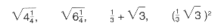
Express each of the rational numbers in the form p/q where p and q are integers.
Answer (b) __________________________________________
___________________________________________________________________________
___________________________________________________________________________
_______________________________________________________________________ [4]

14 A bus company attempted to estimate the number of people who travel on local buses in a certain town. They telephoned 100 people in the town one evening and asked 'Have you travelled by bus in the last week?'
Nineteen people said 'Yes'. The bus company concluded that 19% of the town's population travel on local buses.
Give 3 criticisms of this method of estimation.
Answer ______________________________________________
___________________________________________________________________________
___________________________________________________________________________
___________________________________________________________________________
___________________________________________________________________________
_______________________________________________________________________ [3]

15 The percentage profit, p, on the sale of an item is given by the formula
p = 100 (s - c)
c

where s is the selling price and c is the cost price.
Express c in terms of s and p.
......................................................................................................................................................
......................................................................................................................................................
......................................................................................................................................................
......................................................................................................................................................
Answer __________________________________________ [4]

16 Of 50 Driving School pupils, 30 pass their car driving test at the first attempt. From past performance it is known that, if a pupil fails at the first attempt, the probability of passing at the second attempt is 0.7. Calculate the probability that a pupil, chosen at random from the 50 pupils, will pass the car driving test at either the first or second attempt.
......................................................................................................................................................
......................................................................................................................................................
......................................................................................................................................................
......................................................................................................................................................
......................................................................................................................................................
......................................................................................................................................................
......................................................................................................................................................
Answer __________________________________________ [5]

17
A carton of apple juice has the shape of a cuboid with a square base of side 6.8 cm and a height of 18.4 cm. Each of these measurements is correct to one decimal place.
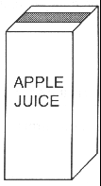
(a) Given that 5000 such cartons must be filled, calculate the volume of juice necessary to be certain of filling all the cartons.
......................................................................................................................................................
......................................................................................................................................................
......................................................................................................................................................
......................................................................................................................................................
Answer (a) ______________________________________ [4]
(b) Calculate the maximum number of cartons that could be filled with this volume of juice.
......................................................................................................................................................
......................................................................................................................................................
Answer (b)_______________________________________ [2]

18 (a)
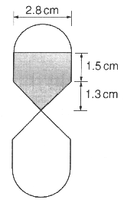
NOT TO SCALE
A symmetrically shaped timer is made from hollow hemispheres, cylinders and cones joined together as shown in the diagram. It contains sand just sufficient to fill the top cone and cylinder sections.
Calculate the volume of sand.
....................................................................................................................................................
......................................................................................................................................................
......................................................................................................................................................
......................................................................................................................................................
......................................................................................................................................................
Answer (a) __________________________________ cm3 [4]
(b)
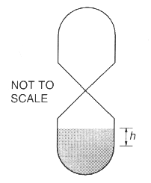
When all the sand has run through, it collects as shown in the diagram. Calculate the height, h cm, of sand in the cylindrical part of the timer.
....................................................................................................................................................
......................................................................................................................................................
......................................................................................................................................................
......................................................................................................................................................
Answer (b) ___________________________________ cm [4]

19 The first one hundred people to enter a cricket ground were asked their ages, which varied between 5 years and 60 years. It was later calculated that the Lower and Upper Quartiles of these ages were 25 years and 38 years respectively.
(a) On the grid, draw a possible cumulative frequency curve.
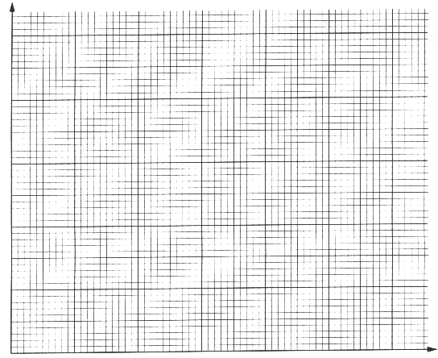
[6]
(b) Use your curve to find the median value. Indicate clearly on your diagram the method you have used.
Answer (b) ______________________________________ [2]
(c) Use your curve to estimate how many of the one hundred people were between 20 and 30 years of age.
......................................................................................................................................................
......................................................................................................................................................
Answer (c) ______________________________________ [1]
(d) What is the probability that a person, chosen at random from the one hundred people, will be at least 18 years of age?
......................................................................................................................................................
......................................................................................................................................................
......................................................................................................................................................
Answer (c) ______________________________________ [3]



